Public Comment on Posts that include “From the River to the Sea”

Authors: David Adesnik and Ahmad Sharawi
Organization: Foundation for Defense of Democracies (FDD)

Issue: The Meta Oversight Board is seeking public comment on the meaning of the phrase “From the river to the sea” used in reference to the conflict between Israelis and Palestinians. The Board specifically asks whether this phrase promotes violence or terrorism and whether it constitutes hate speech, antisemitism, or a call to abolish the state of Israel.

Key Findings: Based on examples of how “From the river to the sea” has been used over the past 50 years, this analysis finds that the slogan originated as a call to abolish the state of Israel and has been used consistently to advocate for that goal. The plain meaning of the phrase “From the river to the sea, Palestine will be free,” is that there should be only one entity, Palestine, between the River Jordan and the Mediterranean Sea. Achieving that goal requires the eradication of the State of Israel.

Relatedly, it is essential to recognize that the common Arabic language equivalent of the phrase in question entails an explicit call for Arab supremacy at the expense of Jews. To this day, protesters on American campuses chant “Min al-mayah lil-mayah, Falastin arabiyah” — literally, “From the water [the Jordan] to the water [the Mediterranean], Palestine is Arab.” Instead of advocating freedom, this version of the slogan explicitly calls for Arab domination in a shared Arab-Jewish space, an antisemitic objective.

A second key finding of this analysis is that those who have employed the phrase “From the river to the sea” have done so in the context of advocating the use of force to abolish the state of Israel. The principal organizations advocating such action reject the characterization of their methods as terrorism, yet those same organizations, including Hamas, repeatedly engaged in the deliberate mass killing of Israeli and/or Jewish civilians.

The third key finding is that the defense of “From the river to the sea” as a non-violent call for liberation originated mainly with anti-Israel protesters in the United States who sought to justify their use of a slogan associated with the violent abolition of the state of Israel. The scholars who argue that the phrase is a call for liberation obscure its origins in their writing.

The fourth and final key finding is that leading U.S. media outlets have failed to examine adequately the history of “From the river to the sea” as part of their efforts to explain its meaning. As a result, they conclude in error that the meaning of the phrase is in the eye of the beholder, so assertions of its inoffensive nature have equal merit to claims that it amounts to a call to eradicate the state of Israel.

Section I: History of the phrase

There is a consensus, as The New York Times correctly reported, that the phrase “dates to the dawn of the Palestinian nationalist movement in the early 1960s.” Nevertheless, early examples of its usage remain elusive. A limited search for the purposes of this comment found relevant examples in English from 1977 and 1981. In December 1977, the phrase appeared in numerous American newspapers after the Libyan leader Muammar Qaddafi used it during an interview with ABC News. On December 5, The Baltimore Sun reported Qaddafi’s view that the Palestinian homeland, “is not just the West Bank of the Jordan River or the Gaza Strip, but also what is now Israel, ‘from the river to the sea.’” In November 1981, a column from The Wall Street Journal included the phrase in the context of a statement from Yasser Arafat broadcast via PLO radio the previous year. Arafat said, “The victorious march will continue until the flag of Palestine is raised above Jerusalem and above the whole area of Palestine from the River to the Sea.” Arafat’s words underscore how “the river to the sea” entails domination over “the whole area of Palestine,” leaving no space for a Jewish state.

The phrase began to appear more frequently in English-language media during the First Intifada. In an interview with the Jerusalem Post dated March 30, 1990, Hamas activist Jamil Hamami said, “There is room for only one state in Palestine, from the river to the sea.” In an article that ran on August 19, 1993, a Miami Herald correspondent spoke with Ibrahim Hassan, a member of a breakaway faction within the PLO that opposed recognition of Israel. “Palestine is ours – from the river to the sea. God willing, we will get it,” said Hassan. In an essay for The Los Angeles Times published on November 21, 1994, author Kenneth Timmerman recounted his discussion with Hisham Ismail Hamad, a member of Palestinian Islamic Jihad, who carried out a suicide bombing operation six days after their encounter. When Timmerman asked Hamad whether the question of Israel’s existence had already been settled, Hamad responded, “We Islamists can never accept such a state. We believe in Palestine from the river to the sea.” Hamad also recommended that Timmerman read The Protocols of the Elders of Zion, adding, “the Jews themselves have revealed their intentions in the Torah. It is all written there. Believe me.”

In 1997, Hamas founder Sheikh Ahmad Yassin held a press conference after his release from an Israeli prison. “Palestine is still occupied, and the HAMAS will not stop the holy war until the liberation of all Palestine from the river to the sea,” he said, according to an account from Agence France Presse dated October 1, 1997. In 2003, Yassin’s deputy, Abdel-Aziz al-Rantisi, led 100,000 demonstrators in Gaza City in a public pledge “to continue jihad and resistance until the restoration of the whole of Palestine from the river to the sea,” per BBC reporting on March 28. Although far from exhaustive, these examples illustrate the intimate association of “from the river to the sea” with explicit calls to eradicate Israel via the use of force.

The meaning of “from the river to the sea” also becomes apparent from cases in which Palestinians or Arab Israelis objected to the slogan because they doubted the wisdom of the effort to eradicate Israel. Their comments show the inextricable relationship between that slogan and the goal of eliminating the Jewish state. In an article dated October 26, 1990, PLO official Faisal Husseini explained to The Jerusalem Post that Palestinians had a right in principle to all the land, but that was not an effective basis for compromise. “If it were, we would insist that our state be from the river to the sea.” Abdullah Darwish, head of Israel’s Islamic Movement spoke with The Jerusalem Report magazine for its edition dated January 28, 1993. “Every Hamas backer has the right to dream of a Palestine from the river to the sea,” Darwish said, “But it is well known in politics that agreements are based on reality, not dreams.” In the 1990s, Palestinians and Arab Israelis who favored co-existence did not seek to redefine “From the river to the sea” as a demand consistent with their agenda. Rather, like those who employed the phrase, they understood that it amounted to a call for Israel’s elimination.

Hamas’s use of the phrase remained consistent during and after the Second Intifada. Often, the context in which speakers employed the phrase underscored the impossibility of any entity other than Palestine existing in the same space. Hamas leader Mahmoud al-Zahar told the Palestinian newspaper Al-Ayyam in 2006, “We want all of Palestine from Naqura to Rafah, and from the sea to the river.” In 2011, Ismail Haniyeh, then serving as Palestinian prime minister, asserted, “Palestine means Palestine in its entirety, from the river to the sea. There will be no concession of a single inch of the land of Palestine.” In 2016, Khaled Meshal, chairman of the Hamas politburo, made clear the racial and religious implications of the phrase. After calling for a Palestinian homeland from the river to the sea, he added, “Palestine was, continues to be, and will remain Arab and Islamic. It belongs to the Arab and the Islamic world. Palestine belongs to us and to nobody else.”

Section II: Usage by protesters in the United States in person and online

One of the distinctive features of protests in the United States is the pairing of the English slogan “From the river to the sea, Palestine will be free,” with the Arabic chant, “Min al-mayah lil-mayah, Falastin arabiyah.” The literal meaning of the latter is “From the water [the River Jordan] to the water [the Mediterranean], Palestine is Arab.” It is not a call for liberty, but a call for the supremacy of one ethnic group and the subordination or elimination of the other. The pairing of these two phrases in American protests indicates the degree to which “From the river to the sea” is inextricably linked to an agenda that seeks domination despite presenting itself as a call for freedom.

Protesters’ use of the “Min al-mayah” chant is deliberate, not impulsive or improvisational. A video from February shows a crowd gathered on the steps of Harvard’s Widener Library, where a woman with a bullhorn is teaching the group to chant, “Min al-mayah lil-mayah, Falastin arabiyah!” At MIT this month, a protester with a bullhorn led the crowd in chanting “Min al-mayah,” then repeated the first half of the slogan while introducing a new ending: “Al-mawt la-sahyuniyah” – “Death to Zionism.” In some instances, protesters and their supporters have explicitly equated the “From the river” with “Min al-mayah,” for example in this social media post from November 2023 by renowned Palestinian poet Tamim Al-Barghouti:



There are also ways in which the English context of “From the river to the sea” can clarify the agenda of eradicating Israel. In a 2016 protest in Chicago, the speaker said, “We don't only think about Al-Quds [i.e. Jerusalem] as that indivisible capital of our nation because we think about Haifa and Jaffa and all the cities inside of what is today called Israel, because that is Palestine too, an indivisible nation of Palestine from the river to the sea that will be free.” The crowd responds by chanting repeatedly, “From the river to the sea, Palestine will be free.”
On Facebook itself, one also sees North American users frequently pairing “From the river to the sea” with its Arabic companion, “Min al-mayah lil-mayah, Falastin arabiyah.” This usage characterizes the accounts of pro-Palestinian organizations as well as numerous private individuals, as these examples illustrate:

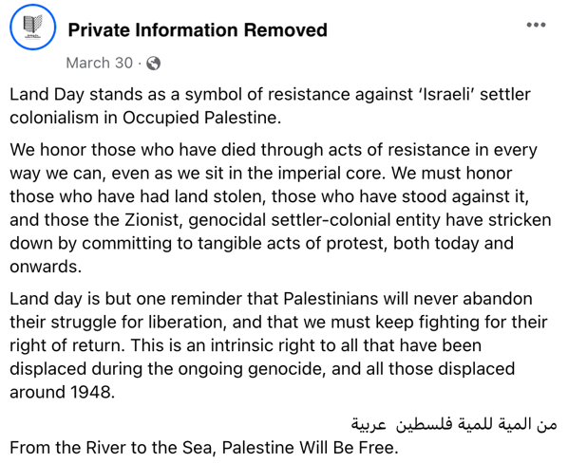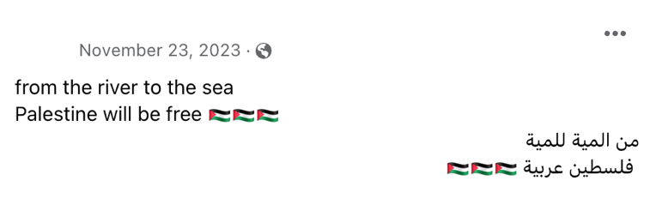

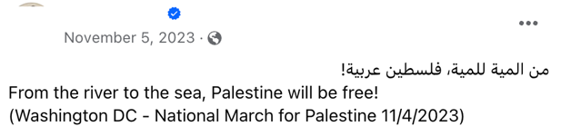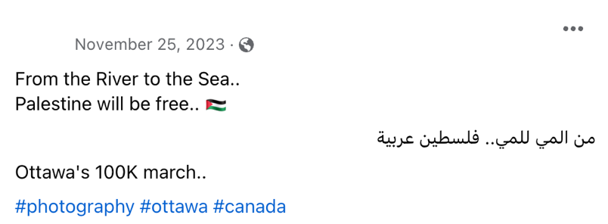

Those who employ the phrase and its Arabic companion are sometimes more explicit about their support for terrorism, explicitly violating Facebook’s community standards. One user who frequently shares footage from protests posted on October 7 that it was the greatest day for Palestine since Saladin’s conquest of Jerusalem in the 12th century. Another user who employs the phrase shared a poem calling on Hamas, specifically its spokesman Abu Obaida, to “strike and burn Tel Aviv.”

In sum, the conduct of protesters and their online supporters demonstrates that “From the river to the sea” remains inseparable from calls for Arab dominion; the connection is not merely historical.

Section III: Legitimizing the slogan – scholarship and press coverage

Academic supporters of the Palestinian cause have sought to legitimize “From the river to the sea” by presenting selective histories of the slogan that obscure its long history as a call to eradicate Israel by force. Two of the most prominent writers to take up this cause are Maha Nassar of the University of Arizona and Yousef Munayyer from the Arab Center Washington DC. In 2018, Nassar asserts the slogan “was part of a larger call to see a secular democratic state established in all of historic Palestine.” She ignores ample evidence (such as the material presented above) that the slogan amounted to a rejection of compromise and support for the use of force to replace the Jewish state with a Palestinian one. Likewise, she ignores that the Arabic companion to “From the river to the sea” — “Min al-mayah lil-mayah, Falastin arabiyah” — is literally a call for Arabic supremacy. Nasser writes, “Dismissing or ignoring what this phrase means to the Palestinians is yet another means by which to silence Palestinian perspectives.” Ironically, it is she who ignores what Palestinians actually meant when using the phrase. In an essay from 2021, Munayyer contends that only those acting out of “earnest ignorance or in bad faith” could interpret the phrase as a call for “dismantling the State of Israel.” Yet like Nassar, he ignores the ample evidence that dismantling the State of Israel was the explicit goal of those who employed the phrase. Similarly, Munayyer avoid any reference to the phrase’s Arabic companion that entails an explicit call to subordinate the Jews.

Building on these justifications, Arab-American leaders and communal organizations have even begun to claim that the phrase embodies a desire for coexistence, even though its historical meaning is precisely the opposite. Rashida Tlaib, the Palestinian-American member of Congress from Michigan, called the slogan “an aspirational call for freedom, human rights, and peaceful coexistence.” The Arab-American Anti-Discrimination Committee likewise insists it is “a demand for democratic coexistence between Jews and Arabs.”

Media coverage tends to attribute equal validity to these distortions as it does to the Jewish community’s view of the phrase as hostile. Most articles conclude, as did the Associated Press, “what the phrase means depends on who is telling the story — and which audience is hearing it.” These articles frequently cite Nassar and Munayyer and fail to present historical evidence that contradicts their preferred narrative. With rare exceptions, new coverage does not mention “Min al-mayah lil-mayah, Falastin arabiyah” or explain it is a call for Arab supremacy.

According to The New York Times, “The decades-old phrase has a complicated back story that has led to radically different interpretations by Israelis and Palestinians, and by Americans who support them.” In a narrow sense, it is true that interpretations of the phrase have diverged, yet the Times and other outlets do not explain that for decades there was a consensus among Palestinians that the phrase entailed a demand to end the existence of the Jewish state, as the first section of this memo has shown. To support its analysis, the Times quotes Nassar, as did The Washington Post, in which Nassar claims the slogan is actually calling for “an imagined future of peace and freedom.”

Conclusion

A decade ago, Americans wrestled with how to regulate the use of a symbol that represented pride and autonomy for one community while standing for violence and intimidation in the eyes of another. For an overwhelming majority of Black Americans, the Confederate battle flag represents slavery, segregation, and lynching. They consider it inseparable from the racist doctrines that justified white supremacy. Nevertheless, a majority of white Southerners considered the flag to be a symbol of “heritage, not hatred.” The flag’s advocates employed selective accounts of history to dissociate the flag from the racism of those who once flew it. What resolved the debate was a massacre that stunned the nation, the 2015 murder of nine Black Americans by a white terrorist at a church in Charleston. His crime demonstrated that the flag was beyond redemption. The same is true of “From the river to the sea” after October 7. It is the slogan of those who planned and carried out the massacre of 1,200 Israelis. For Israelis and for Jews everywhere, “From the river to the sea” can never be a benign call for pride and autonomy after seeing how Hamas put the slogan into practice.

The language in quotation marks is the BBC’s paraphrase of Rantisi, not a verbatim quote.

