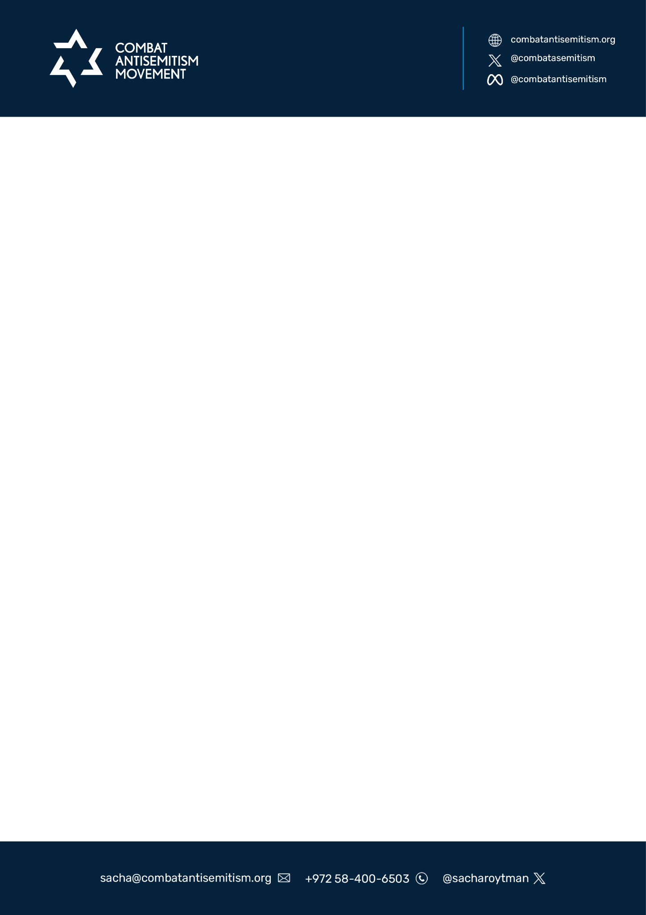  
  
  
 **Understanding the Implications of the Slogan "From the River to the Sea, Palestine Will Be Free"**

**By the Combat Antisemitisim Movement To Meta Oversight Board**

This white paper aims to analyze the slogan "From the River to the Sea, Palestine Will Be Free," its historical and contemporary contexts, and why it is perceived as a call to violence against the State of Israel. This slogan suggests the complete liberation of Palestine, covering the territory from the Jordan River to the Mediterranean Sea, which encompasses the entire State of Israel. We will explore the implications of this slogan, its impact on the Israeli-Palestinian conflict, and its reception by different communities and international bodies.

**Introduction**

The phrase "From the River to the Sea" refers geographically to the land between the Jordan River and the Mediterranean Sea, encompassing the modern-day state of Israel, the West Bank, and Gaza Strip. Historically, this slogan has been associated with groups that oppose the existence of Israel as a Jewish state, such as [Hamas](https://www.dni.gov/nctc/groups/hamas.html), [Hezbollah](https://www.dni.gov/nctc/groups/hizballah.html), and [Palestinian Islamic Jihad](https://www.dni.gov/nctc/ftos/pij_fto.html). Since their inception, these terror organizations have advocated for the obliteration of the world’s only Jewish state as a precondition to the establishment of a Palestinian state. This position is clearly outlined in the 1988 [Hamas Charter](https://avalon.law.yale.edu/20th_century/hamas.asp), which states categorically that “In face of the Jews' usurpation of Palestine, it is compulsory that the banner of Jihad be raised.”

**Historical Context**

The core of the antisemitic interpretation stems from the implication that the slogan calls for the elimination of the state of Israel. The phrase suggests a vision where Jews would either be expelled from the territory or become an ethnic minority in an Arab-majority state. This scenario raises concerns that Jews would be subjected to institutionalized antisemitism by Palestinian leaders who have historically [supported](https://palwatch.org/page/18191), [glorified](https://palwatch.org/page/29438), and [funded](https://jcpa.org/paying-salaries-terrorists-contradicts-palestinian-vows-peaceful-intentions/) acts of terror against Israeli civilians. Furthemore, the [expulsion](https://www.jewishvirtuallibrary.org/jewish-refugees-from-arab-countries) of more than 850,000 Jews from Arab lands across the Middle East and North Africa following the establishment of the State of Israel is a testament to the fate that would await a Jewish minority population in an Arab majority state.

Antisemitism has historically manifested in efforts to deny Jews a place in society, including systematic discrimination, expulsions, and genocides. The modern state of Israel represents a successful liberation movement that has restored Jewish sovereignty to its ancestral homeland and served as a response to centuries of persecution. Therefore, a slogan advocating for the dissolution of Israel is seen as a continuation of these historic efforts to marginalize and disenfranchise Jews. By framing the issue in terms of geographic eradication rather than coexistence, the slogan echoes these past injustices.

**Interpretation and Implications**

The geographical reference "from the river to the sea" encompasses all the land between the Jordan River and the Mediterranean Sea. Which is all the the land where Israel has been founded. In this exact land live more than 9 millions Israelis, Jews, Muslims, Christians, and more.

While some proponents of the slogan argue that it simply advocates for Palestinian self-determination and an end to the Israeli occupation of the West Bank and Gaza, the phrase's [broader](https://x.com/karenievers/status/1761082103066755530?s=12&t=LMXebXbwXQ6y7VSq3G7x2w) and more militant associations cannot be ignored. The slogan has been [chanted](https://x.com/RetsefL/status/1781725305398243425) at rallies and [events](https://x.com/Shomrim/status/1756746847815713140?s=20) where anti-Israel sentiments are high, often accompanied by rhetoric that denies Jewish ties to the land, praises Palestinian terrorism, and distorts the memory of the Holocaust.

By advocating for a free Palestine within these borders, the slogan implies the complete dissolution of Israel as a sovereign state. This interpretation is seen by many as a call for the removal of the Jewish state and the displacement of its Jewish residents. It is a call for genocide and ethnic cleansing. When connected to the October 7 violence the call to commit a genocide has moved from hate speech to pratical implementation. As since October 7 all the calls using the slogan “ From the River to See Palestine will Be Free” are now seen as an attempt to implement the slogan and eventually commit a full genocide all on those leaving between the rive and the sea.

**Political and Social Implications.**

The slogan is perceived by many as a call to violence for several reasons:

1. Elimination of the State of Israel: The explicit call for a free Palestine within these borders suggests the end of Israel's existence. This is seen as an existential threat by Israelis and their supporters.
2. Displacement of Jewish Residents: The slogan implies that all current inhabitants who do not identify as Palestinian would be expelled or forced to leave. This raises concerns about ethnic cleansing and forced displacement.
3. Historical Context of Violence: The groups and movements that have historically used this slogan, such as Hamas, have been involved in violent conflicts with Israel. The slogan is thus associated with a history of terrorism and armed struggle against the Israeli state.

**International Response**

The international community is divided on the Israeli-Palestinian conflict. However, the slogan "From the River to the Sea, Palestine Will Be Free" is widely seen as problematic. Many countries and international organizations recognize Israel's right to exist and advocate for a two-state solution, where both Israelis and Palestinians can live in peace within their own sovereign states.

**Conclusion**

The slogan "From the River to the Sea, Palestine Will Be Free" is a deeply controversial and polarizing phrase. While it represents the aspirations of some Palestinian groups, it is perceived by many as a call to violence against the State of Israel and its Jewish population. Understanding the historical and contemporary contexts of this slogan is crucial for comprehending its implications and the broader Israeli-Palestinian conflict.

**Recommendations**

To foster a more constructive dialogue, it is recommended that:

* **Ban:** We call on Meta to ban the use of this slogan as hate speech.
* **Promote Peaceful Advocacy:** Encourage the use of language that supports coexistence and mutual recognition rather than calls for the elimination of any state.
* **Educate on Historical Contexts:** Provide comprehensive education on the historical and contemporary contexts of the Israeli-Palestinian conflict to foster understanding and empathy on both sides.